Trabajos sobre SQL

# Dirección de la base de datos

host:pgadmin.jvh.kfs.es

port 5433

database: postgres

user:lector

password:lector

host:database-1.csaavemoe4v5.us-east-1.rds.amazonaws.com

port:5432

database:postgres

user:lector

password:lector

# W3Schools

Este tutorial y el cuestionario posterior van a servir para consolidar conocimiento.

Es posible que encontremos algo de sintaxis diferentes que es dependiente del motor de base de datos.

<https://www.w3schools.com/quiztest/quiztest.asp?qtest=SQL>

<https://www.w3schools.com/sql/default.asp>

# Herramientas cliente para database

JET BRAINS. Para mí el cliente mejor que hay. Maneja casi todas las base de datos.

<https://www.jetbrains.com/datagrip/?source=google&medium=cpc&campaign=15034927855&gclid=CjwKCAiAg6yRBhBNEiwAeVyL0Fhmk1SijX1ThUbFSsq-QJnSkzPT0Qw7eIhQ9K8Aq1o5kogpIXgllhoCOmQQAvD_BwE>

30 days free

EXTENSION PARA VSCODE

Video de ayuda para instalar la extensión

<https://www.loom.com/share/7fa91737e358467090a9d37c74437d2c>

Tiene la ventaja del copilot

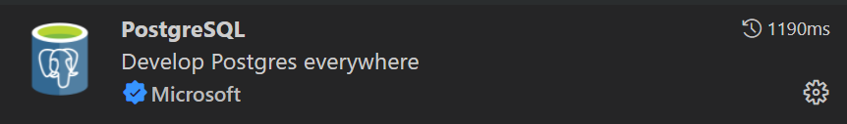

# Modelo que vamos a usar

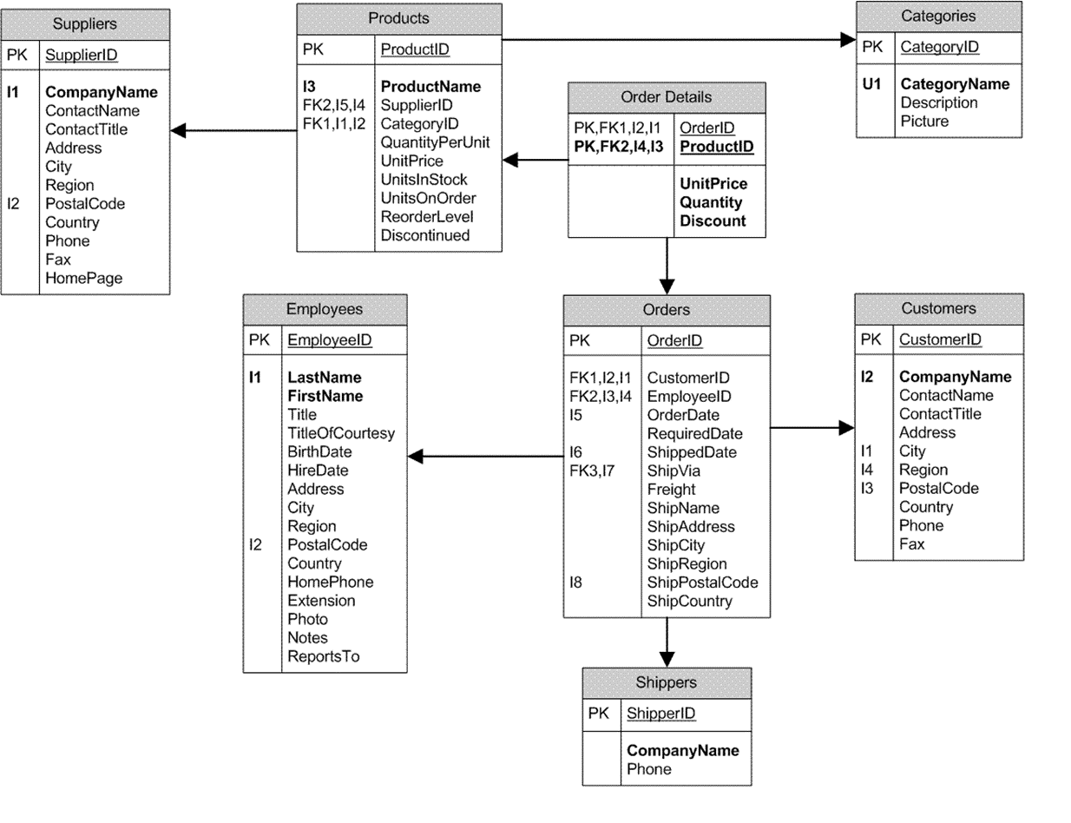

# Ejecutar las queries

## Simples

1. Facturas del año 1998
2. Lista de productos: Identificativo, Nombre y precio ordenado por Nombre.
3. Lista de facturas de marzo del 1996
4. Facturas de cliente cuyo id = ‘VINET’

## Join

1. Clientes que tienen facturas en 1997
2. Nombre de productos vendidos en factura 10248
3. Facturas de clientes de Madrid
4. A qué cliente hemos vendido el producto con id 72
5. Clientes que han comprado en enero y febrero de 1997
6. Productos que no se han comprado nunca

## GroupBy

1. Importe de la factura 10248
2. Importe de facturas de clientes por Country.
3. Facturas emitidas por año y country
4. A quienes hemos hecho más de 3 facturas en 1998.
5. Lista de ventas por año y producto (nombre, importe)
6. Ventas por categoría y año y mes.
7. Ventas por países y año
8. Número de envíos realizado por ship_via.
9. A que países van los transportistas (ship_via y ship_country)

# Decir lo que hacen las siguientes select

Estas son las select que se hicieron en la sesión

select * from

orders o,

order_details od

where

o.order_id = od.order_id and

product_id = 8;

select DISTINCT order_date

from orders o, order_details od

where

o.order_id = od.order_id and

product_id = 8

order by order_date;

select * from

customers c, orders o, order_details od

where

c.customer_id = o.customer_id and

o.order_id = od.order_id;

select products.* from products

inner join

order_details od on products.product_id = od.product_id

where od.product_id is null;

select country, city, count(*)

from customers

group by country, city

order by country, city;

select company_name, count(*) FROM

customers c, orders o

where

c.customer_id = o.customer_id

and extract(year from order_date) = 1997

group by company_name

ORDER BY company_name;

select extract(year from order_date) as anio, count(*)

from orders

group by extract(year from order_date);

select od.order_id, sum(unit_price * quantity) as total

from order_details od

inner join orders o on od.order_id = o.order_id

where o.customer_id = 'BLONP'

and o.order_date >= '1997-01-01'

and o.order_date <= '1997-12-31'

GROUP BY od.order_id;

order by total desc, od.order_id;

select company_name,

sum(unit_price * quantity * (1 - discount)) as total

from customers c inner join orders o

inner join order_details od

on od.order_id = o.order_id

on c.customer_id = o.customer_id

GROUP BY company_name

order by 1;

select company_name,

sum(unit_price * quantity * (1 - discount)) as total

from

customers c,

orders o,

order_details od

where

c.customer_id = o.customer_id and

o.order_id = od.order_id and

extract(year from order_date) = 1997

GROUP BY company_name

order by 1;

select company_name, count(*)

from

customers inner join orders o

on customers.customer_id = o.customer_id

GROUP BY company_name

HAVING count(*) > 10

order by 2;

select

c.*

from

customers c,

orders o,

order_details od

where

c.customer_id = o.customer_id and

o.order_id = od.order_id AND

od.product_id = 11

select extract(year from order_date) aaaa,

product_name,

sum(quantity)

from

orders o ,

order_details od,

products p

where

o.order_id = od.order_id and

od.product_id = p.product_id

group by

extract(year from order_date),

product_name

order by 1 , 3 desc, 2;

select company_name, count(*)

from

customers c,

orders o

where

c.customer_id = o.customer_id

group by company_name

having count(*) > 10

order by 2 desc;

insert into borrame as

select extract(year from order_date), company_name, sum(quantity * unit_price * (1 - discount)) as total

from

customers c,

orders o,

order_details od

where

c.customer_id = o.customer_id and

o.order_id = od.order_id

group by extract(year from order_date), company_name

order by 1, 3 desc;

select * from borrame;